**SSN College of Engineering**

**Department of Computer Science and Engineering**

**UCS1512 – Microprocessors Lab**

**EX:13 – Cube of a number using 8051**

Exp No: 13 Name : Kshitij Sharma

Date: 22/10/2020 Reg No: 185001080

**AIM:**

To implement a 8051 ALP to find cube of a number.

**ALGORITHM:**

* Move the value in R1 to register A and B and backup A’s value in R0.
* Multiply A and B using MUL AB with higher order bits in B and lower order bits in A.
* Since the number is from 0 to F, higher order bits will be 00H.
* Move the value in R0 to register B.
* Multiply A and B using MUL AB with higher order bits in B and lower order bits in A.
* Move the register B’s value to R2 and register A’s value to R3.
* HERE: Infinite loop to HERE using SJMP HERE.

|  |  |  |
| --- | --- | --- |
|  | **Program** | **Comments** |
|  | MOV A, R1 | A <- R1 |
| MOV B, A | B <- A |
| MOV R0,A | R0 <- A |
| MUL AB | BA <- A x B |
| MOV B, R0 | B <- R0 |
| MUL AB | BA <- A x B |
| MOV R3, A | R3 <- A |
| MOV R2, B | R2 <- B |
| HERE: | SJMP HERE | Transfers execution to HERE. |

**SNAPSHOT OF SAMPLE I/O:**

**Input: R1=09**

**Output: R2=02 R3=D9**

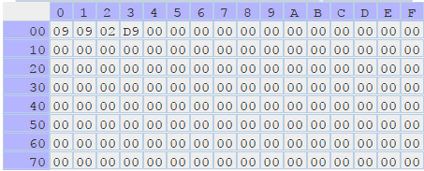

**RESULT:**

Thus the 8051-program for finding cube of a number (0 – F) is executed successfully.